Eric Dinh

May 11, 2024

QUIZ 4-8

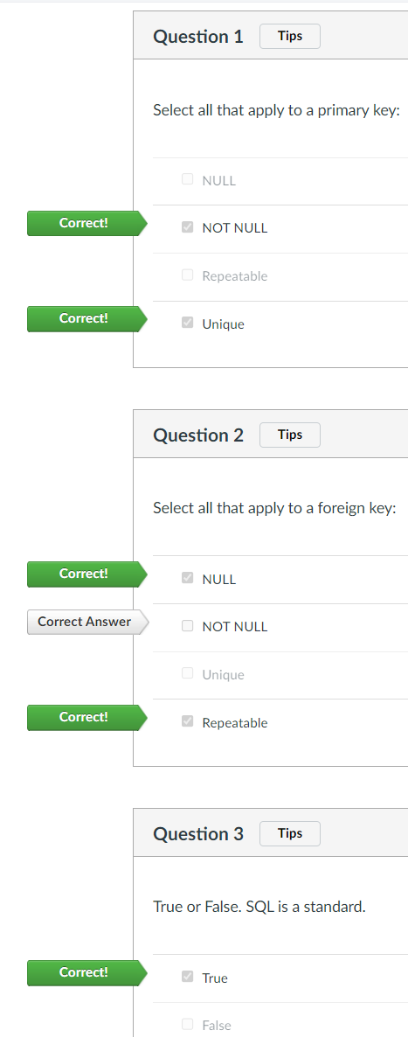

Web Server Technologies

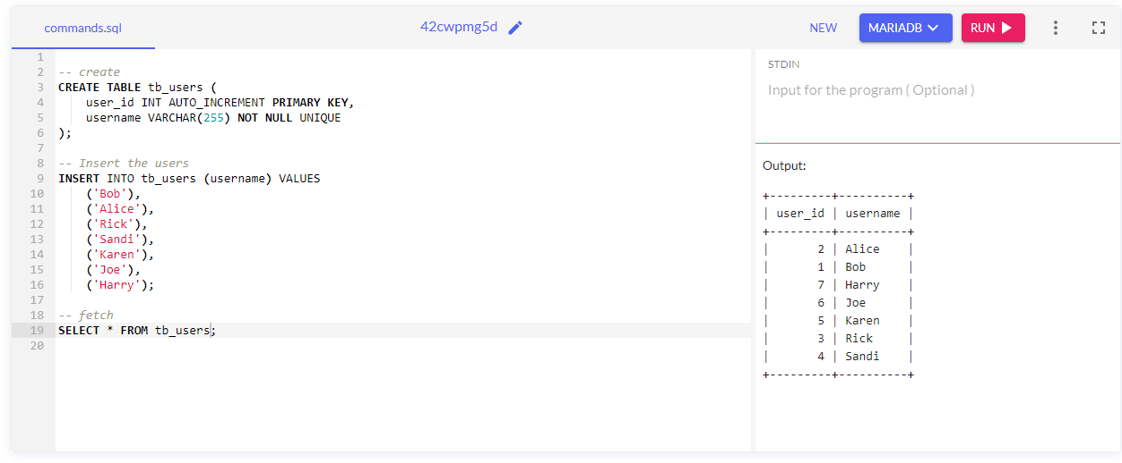

I was unable to create a database in the website due to permission issues. I was only able to create tables and enter values into the tables.

To create a database and use it:

CREATE DATABASE db_blod;

USE db_blod;